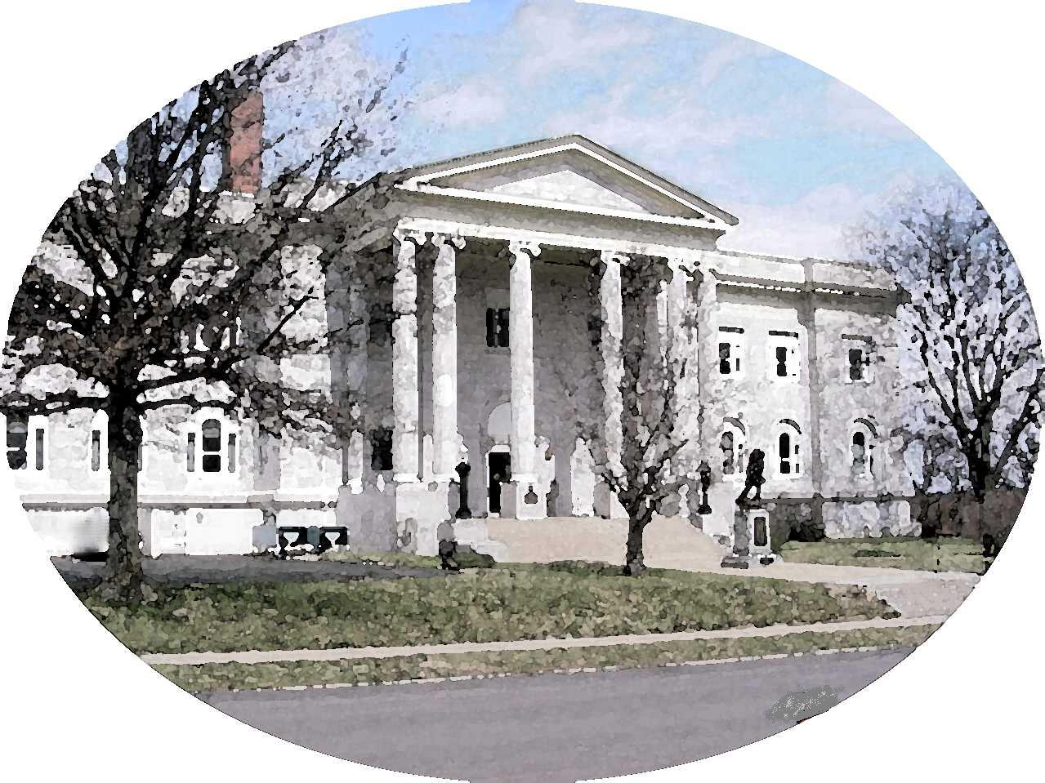

COUNTY OF LEAVENWORTH

300 Walnut St – Suite 105
Leavenworth, Kansas 66048-2725
(913) 684-0430
Fax (913) 684-0436

From the office of Janice Van Parys, County Treasurer
Email: jvanparys@leavenworthcounty.org

REFUND INSTRUCTIONS

Kansas statue allows for a refund of the unused portion of the motor vehicle taxes if the resident of Kansas has established residence in another state.

Instructions: The following items shall be submitted to the County Treasurer’s Office in which the motor vehicle was registered.

- Kansas owner’s registration receipt, or enclose 1.00 for a duplicate.

- A copy of the applicant’s current out-of-state registration.

- A copy of the applicant’s current out-of-state Driver’s License.

- The Kansas registration license plate. (If applicable)

( ) a. If the state you are currently residing in required you to surrender your Kansas License plate, please check this box to the left.

- PLEASE RETURN THIS FORM WITH OTHER SUPPORTING DOCUMENTATION.

- SOCIAL SECURITY NUMBER _____________________________________

SIGNATURE ______________________________________________________

If the vehicle was leased, we need a copy of the lease agreement or a relinquishment from the leasing company in order for the check to be made to you and/or your leasing company.

The Division of Vehicles has developed these instructions. Law requires items 1, 2, & 3. Law also requires item 4 if applicable.

Refunds of less than ($5.00) will not be processed.

Mail Documents to: Leavenworth County Treasurer
300 Walnut St. Ste 105, Leavenworth, KS 66048

